Terms of Reference
  - Local consultant to support Country Coordinating Mechanism Positioning (may be modified for country context)
Updated: July 2021
Context | The Global Fund’s Country Coordinating Mechanism (CCM) Policy outlines that the CCM should be positioned at the highest level responsible for multi-partner and multi-sectorial development planning in a country. The Global Fund encourages all countries to build on their national structures, wherever possible, and to position the CCM and/or CCM functions within existing health platforms to contribute to central coordination of health programs, investments and pandemic preparedness. In countries actively preparing for transitioning away from Global Fund financing for at least one disease component, positioning planning and implementation may imply more urgent timelines. These two points should be used to adapt the role of the CCM to support a successful transition process and to promote increased sustainability. This can include gradually shifting essential CCM functions and principles to national health institutions as early as possible for proactive transition planning, rather than waiting for a transition grant. Mapping existing health governance bodies in a country is the first step towards institutionalizing CCM functions.
Scope/  Objective | The local consultant will identify existing national health structures, governance mechanisms and platforms responsible for coordinating the health sector and disease-specific issues. For the transition context, this should have an added focus on key national stakeholders that are most appropriate for strengthening transition planning, preparedness, implementation, and overall efforts to strengthen sustainability.  The consultant will map each identified platform’s position within the national systems and in relation to the CCM. The consultant will also support the CCM in developing a Positioning plan based on three main phases (refer to the Positioning Guidance Note):  - Knowledge  - Coordination  - Sustainable Structure.
Tasks and Metrics | The local consultant is expected to perform the following tasks:  Task Metric  Understand and become familiar with the principle of Positioning. For the transition context, understand the transition lens and how it fits within Positioning. Positioning e-Learning module and review of Positioning Guidance Note completed.  Undertake a desk review of relevant documents. - Governance documents of up to 10 health governance bodies reviewed (CCM included). - When available, Sustainability and Transition assessment reviewed.  Interview key stakeholders at the national level. At least one stakeholder per governance body interviewed, including one high-level government official.  Map existing national health structures. Organigram showing the positions and relations of up to 10 health governance bodies (CCM included). The organigram can be completed manually or using a software solution provided by the Global Fund (Visio).  Develop a summary report. Report drafted (2-4 pages) with thematic tables and analysis on: - Mandate - Composition - Structure - Legal Status - Anchorage level to the national system.  Organize an in-country consultation meeting. - Presentation on key results - Moderated sessions on the following phases of the CCM Positioning journey: Coordination, Sustainable Structure. The consultation should bring together stakeholders on coordinating and aligning platforms and include the civil society voice.  Support the CCM Evolution Task Force, CCM Executive Committee and CCM Secretariat to develop a CCM Positioning plan. Proposal developed on the appropriate positioning of the CCM. It should include: - Necessary linkages and alignment with other significant coordinating platforms in-country. For the transition context, this includes identifying key national stakeholders, including non-CCM members, that can support national transition planning and implementation, and overall efforts to strengthen sustainability. - Long-term embedment of CCM functions within existing or emerging health platforms, including ensuring strong inclusion of civil society and participating in efforts to strengthen sustainability of Global Fund investments.
Deliverables | Deliverable Content Level of effort (LoE)  Mapping of existing national health platforms The map should show the national structures and their relationship within the national health sector. 15 LoE  Brief summary report (2-4 pages) An executive summary of key findings, conclusions, options and next steps (including activities for inclusion in baseline assessment work plan – optional based on country context). 2 LoE  Power Point Presentation Key findings and conclusions from the mapping exercise. 1 LoE  Positioning plan Plan with cleared outlined deliverables, steps and timeline. 7 LoE
Reporting Lines | The consultant will report to the CCM Executive Committee and the Chair of the CCM Evolution Task Force.  The consultant will work in close collaboration with the CCM Secretariat and the CCM Evolution Task Force.  The CCM Secretariat is requested to share the consultant’s deliverables with the Global Fund.
Level of effort and period of performance | The consultant has 25 LoE to be used over a period of 2 months.
Annexes | Annex 1: Example of Positioning map (designed with software Visio).  Annex 2: Example of Positioning map (manually built).

Candidate Profile | A. Qualifications  Essential:  Advanced degree in public health, finance, public administration or business administration, or related field.  B. Experience  Essential:  - Solid experience in developing partnerships in political environments and in mediating complex issues and deliverables at country, regional and international levels.  - Rich professional experience, including a track record of working in strategy and policy analysis, program planning and management, and/or equivalent experience.  - Solid understanding and experience of strategic, organizational, financial and management issues.  - Solid understanding of the Global Fund processes and of its funding model.  - Excellent written and verbal communication skills.  Desirable:  - At least 3 years of professional experience (international or national) working in planning and management in the humanitarian sector.  - Experience in public health and disease program management with focus on HIV and AIDS, tuberculosis and malaria.  - Documented experience of coordination across multiple stakeholders.  C. Competencies  Languages:  Working level of English as well as knowledge of the local language (particularly the one most widely spoken by key population representatives) are a requirement for this role.  Technical skills:  - Robust knowledge of the software Visio.  - Proficiency in Microsoft Office applications especially Excel/ Access, email, internet and websites essential.  - Robust understanding of governance matters.  - High degree of organization, initiative and political awareness.  - Knowledge of public health issues.  - Strong interpersonal skills and proven ability to communicate and interact with high-level officials from the government, NGOs, UN agencies and the private sector.  - Strong writing, presentation and communication skills and IT competences are essential.  - Ability to lead a team and set priorities while handling multiple tasks simultaneously.  - Previous development experience and/or background with government or private sector desirable.

Annex 1: Example of Positioning Map (Designed with Visio Software)
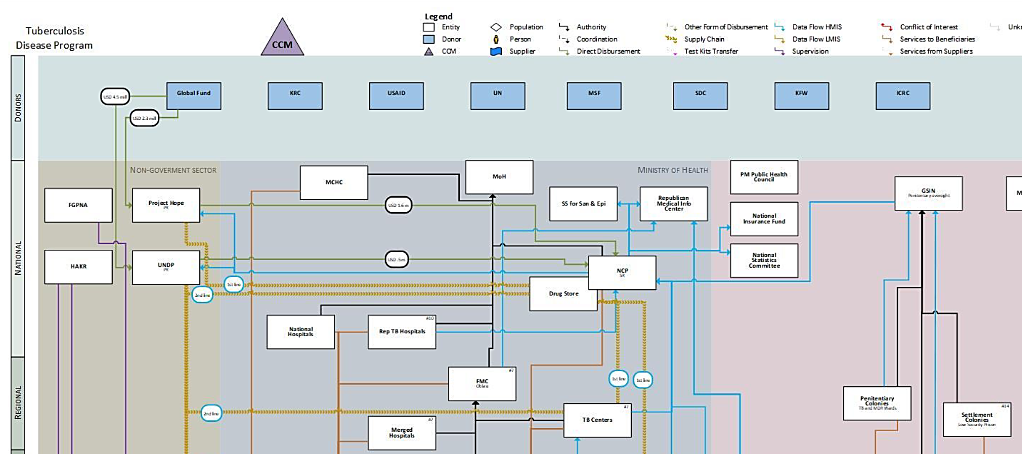

Annex 2: Example of Positioning Map (Manually Built)
Prime Minister’s Office
CNLS (NAC)

National Health Sector Coordinating Committee (HSCC)
(multisectoral)
Emergency Response Coordination Body

CCM Sub-Committees
Ministry of Health
CCM
National Disease Programs
Ministry of Budget
HSCC Technical Secretariat

GAVI committee
Department of Planning and
Cooperation
Formal linkage
Informal linkage for communication and collaboration

Countries will be informed if they are in the transition context

